MYSQL PRACTICAL

Q1 : CREATE A DATABASE

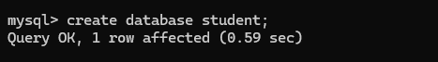

Q2 : USE DATABASE



Q3 : CREATE TABLE



Q4 : DESCRIBE TABLE

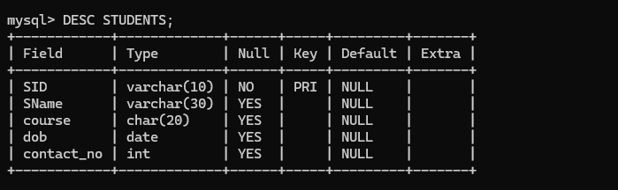

Q5 : INSERT VALUES

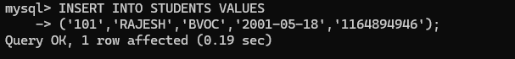

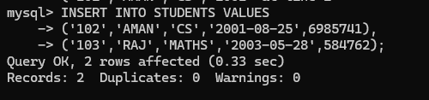

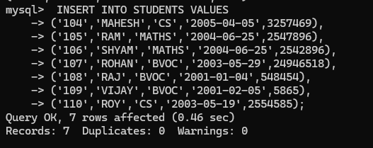

Q7 : SHOW VALUES FROM TABLE

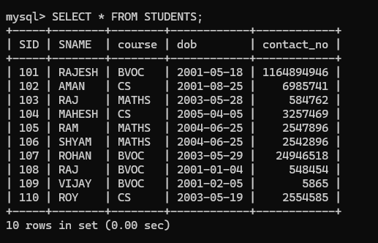

Q8 : FIND OUT THE NAME AND COURSE OF THE STUDENT WHOSE DATE OF BIRTH IS BETWEEN 2004 AND 2006.

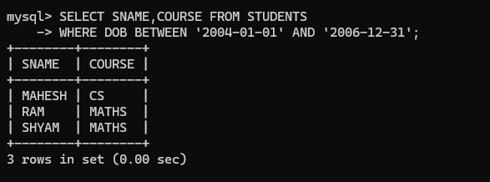

Q9 : DISPLAY THE STUDENT WHO IS STYDING IN CS COURSE.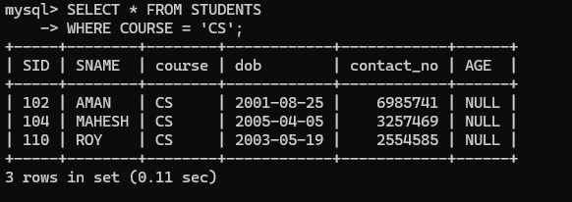

Q 10: CALCULATE THE AGE OF THE ALL STUDENTS.

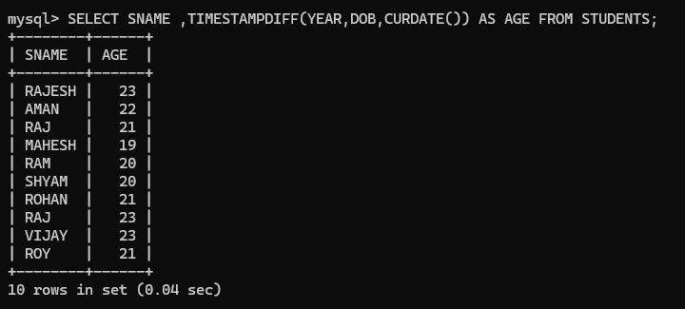

PRACTICAL 1

CREATE DATABASE STUDENT_COURSE

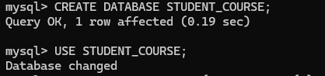

CREATE STUDENT TABLE



CREATE COURSE TABLE



CREATE ADMISSION TABLE

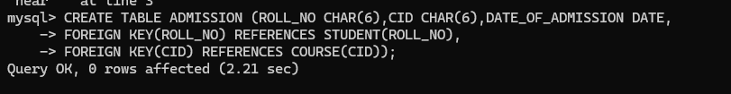

DESCRIBE STUDENT TABLE

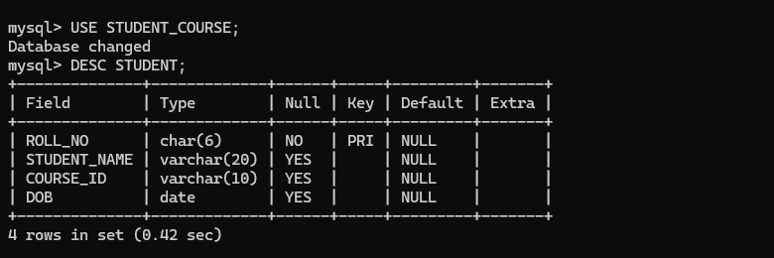

INSERT VALUES INTO STUDENT

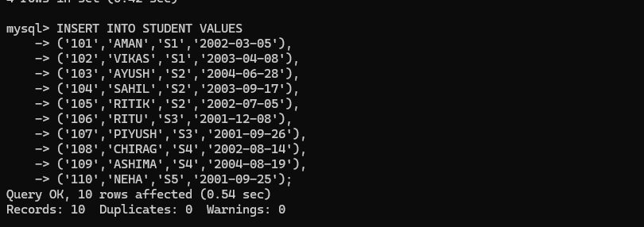

RETREIVE VALUES FROM STUDENT TABLE

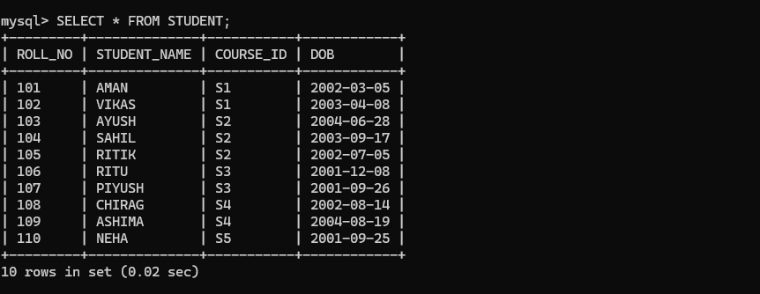

DESCRIBE COURSE TABLE

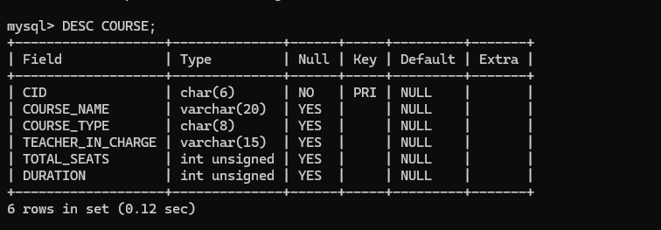

INSERT VALUES INTO COURSE

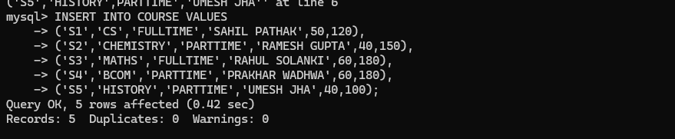

RETREIVE VALUES FROM COURSE TABLE

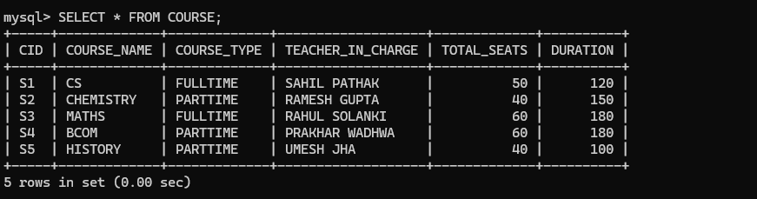

DESCRIBE ADMISSION TABLE

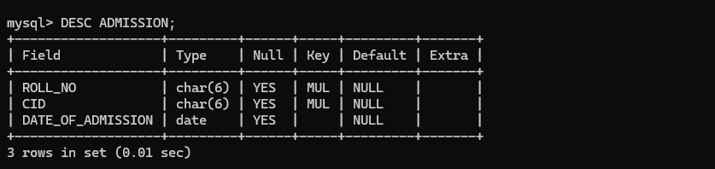

INSERT VALUES INTO ADMISSION

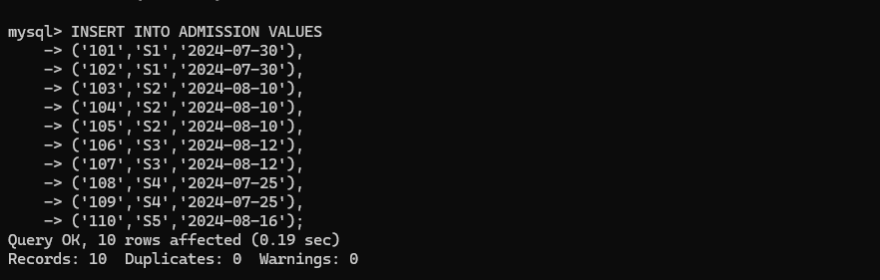

RETREIVE VALUES FROM ADMISSION TABLE

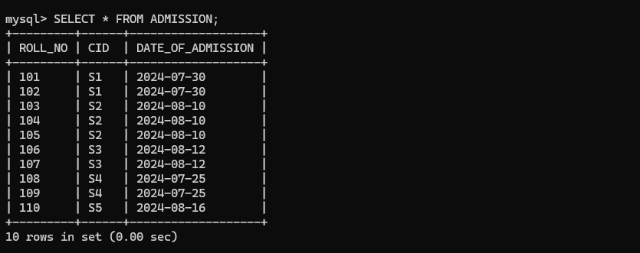

1. Retrieve names of students enrolled in any course.

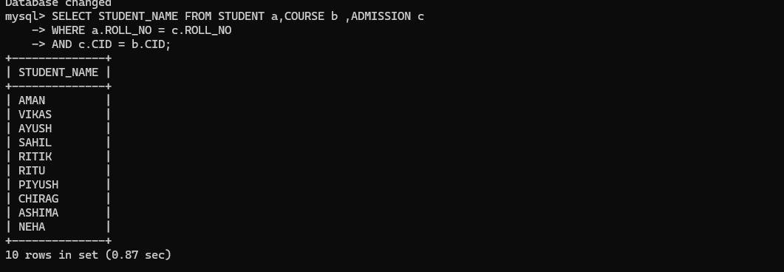

1. Retrieve names of students enrolled in at least one part time course.

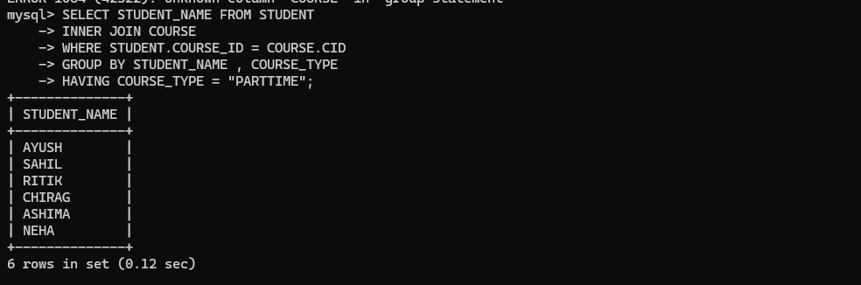

1. Retrieve students' names starting with letter ‘A’.

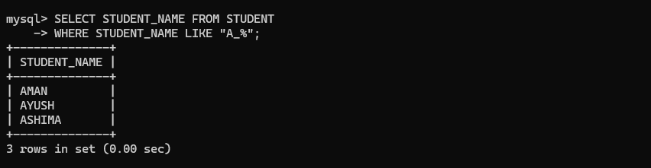

1. Retrieve students' details studying in courses ‘computer science’ or ‘chemistry’.

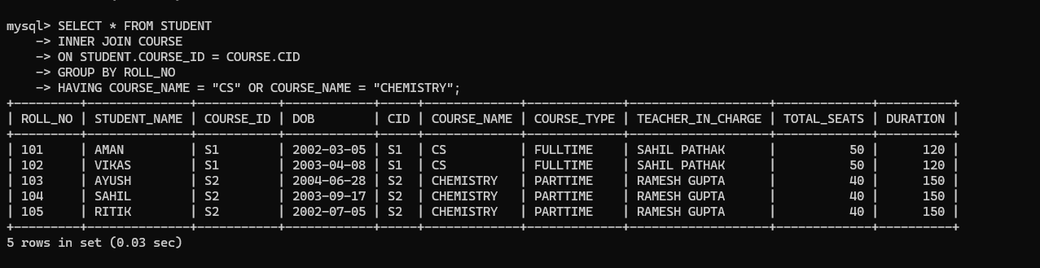

5. Retrieve students’ names whose roll no either starts with ‘X’ or ‘Z’ and ends with ‘9’

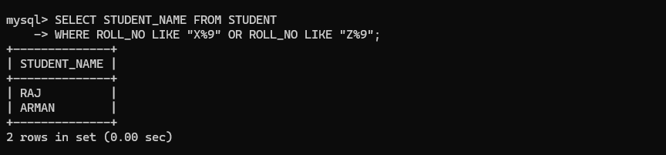

6.Find course details with more than N students enrolled where N is to be input by the user.



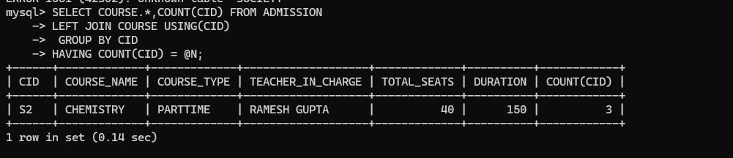

7.Update student table for modifying a student name.

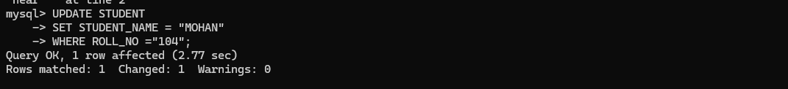

8. Find course names in which more than five students have enrolled

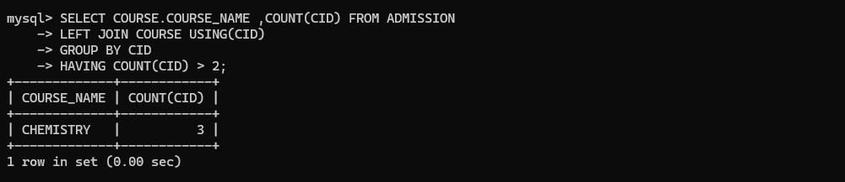

9. Find the name of youngest student enrolled in course ‘BSc(P)CS’

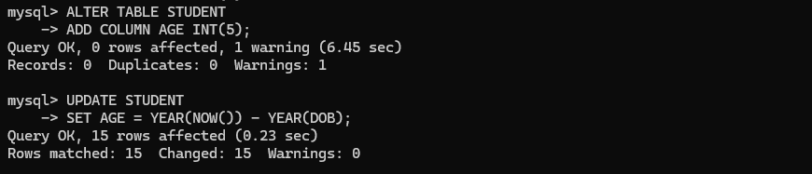

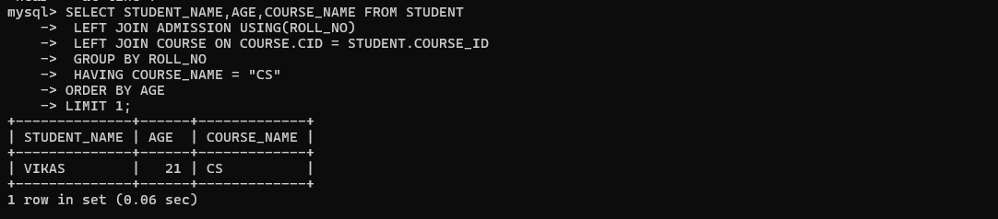

10. Find the name of most popular course (on the basis of enrolled students)

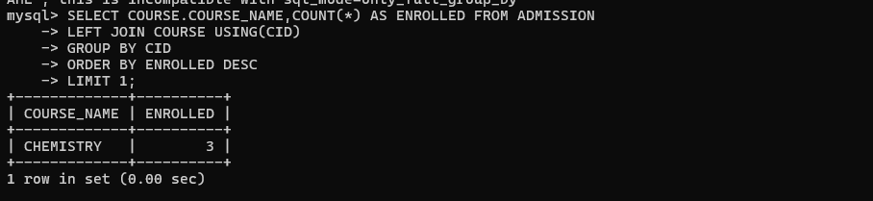

11. Find the name of two popular part time courses (on the basis of enrolled students)

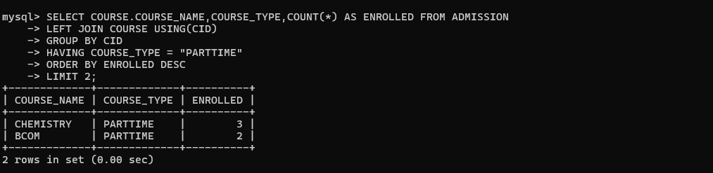

12. Find the student names who are admitted to full time courses only.

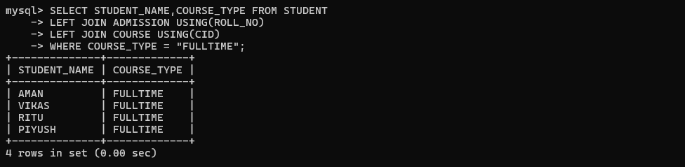

13. Find course names in which more than 30 students took admission.

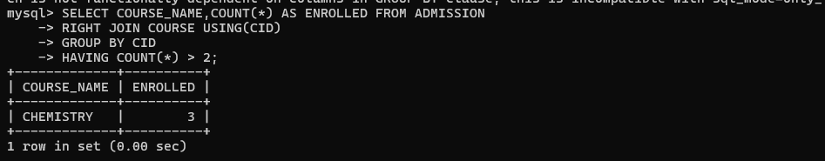14. Find names of all students who took admission to any course and course names in which at least one student has enrolled.

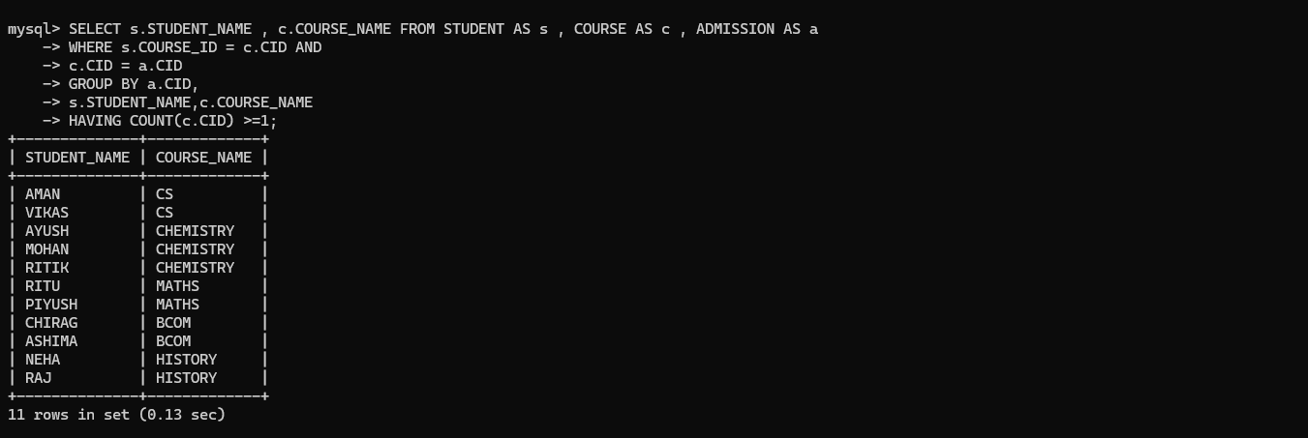

15. Find course names where teacher-in-charge has ‘Gupta’ as surname and the course is full time.

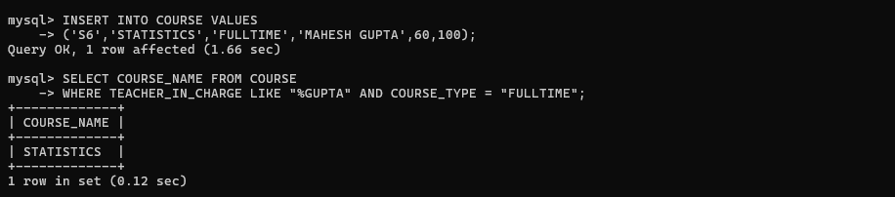

16. Find the course names in which the number of enrolled students is only 10% of its total seats.

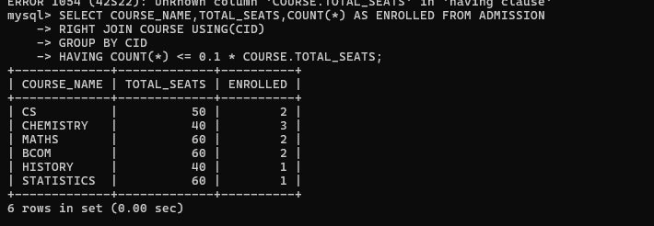

17. Display the vacant seats for each course .

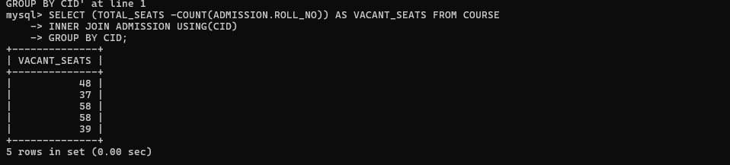

18. Increment Total Seats of each course by 20% .

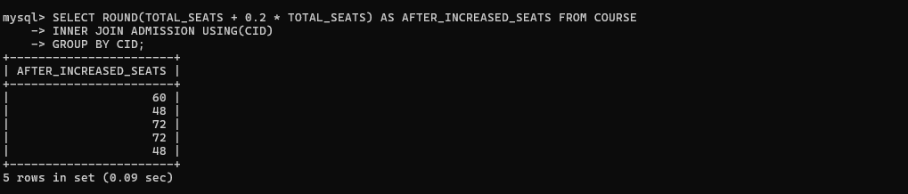

19. Add enrolment fees paid (‘yes’/’No’) field in the enrolment table.

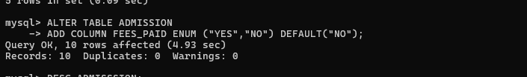

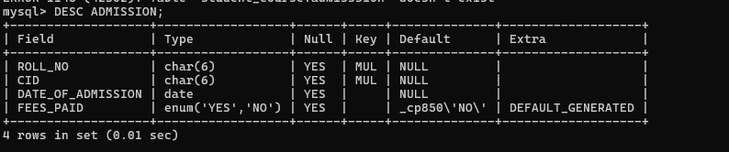

20. Update the date of admission for all the courses by 1 year.

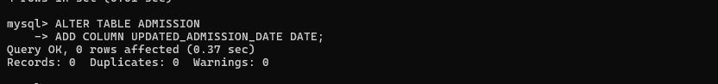



21. Create a view to keep track of course names with total number of students enrolled in it.

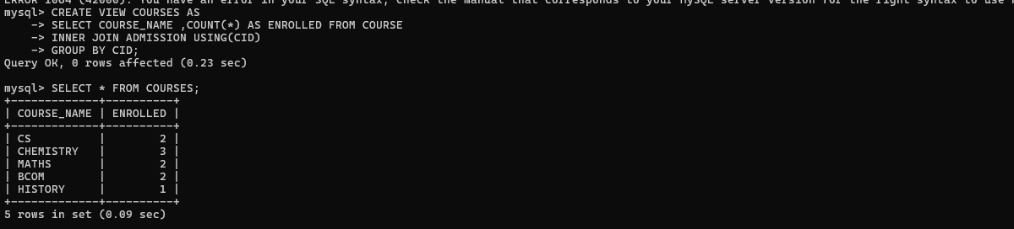

22. Count the number of courses with more than 5 students enrolled for each type of course.

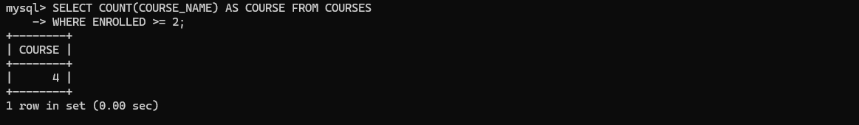

23. Add column Mobile number in student table with default value ‘9999999999’

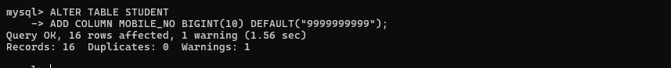

24. Find the total number of students whose age is > 18 years.

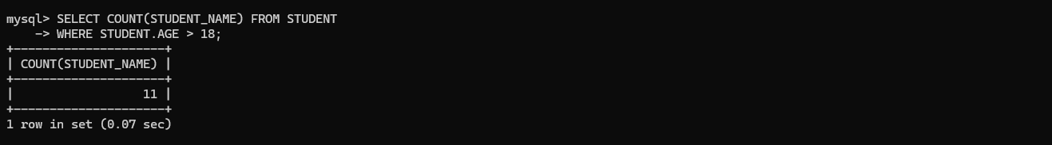

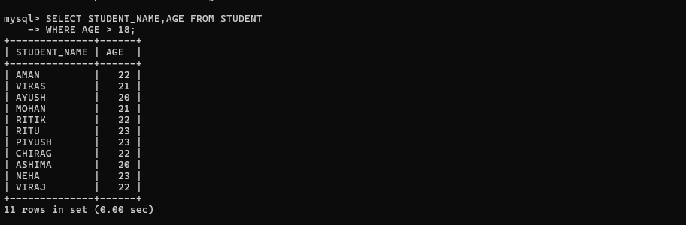

25. Find names of students who are born in 2001 and are admitted to at least one part time course.

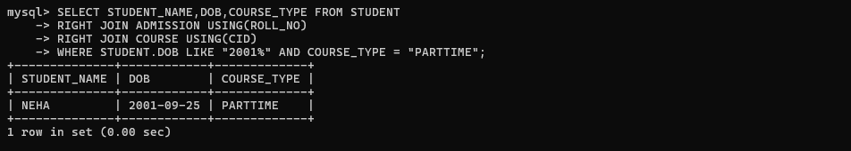

26. Count all courses having ‘science’ in the name and starting with the word ‘B.Sc.’.

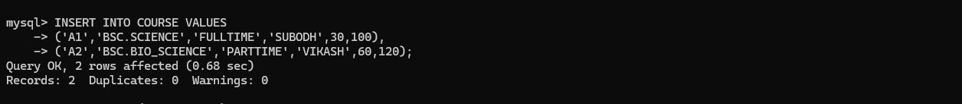

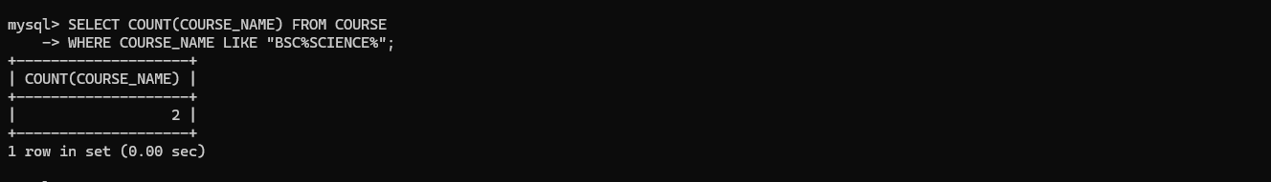

Practical 2:

Create the following tables with appropriate data type for attributes and integrity constraints on the tables. Enter at least 5 records in each table and answer the queries given below.

Suppliers (SNo, Sname, Status, SCity)

Parts (PNo, Pname, Colour, Weight, City)

Project (JNo, Jname, Jcity)

Shipment (Sno, Pno, Jno, Quantity)

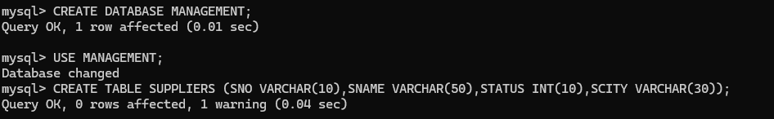

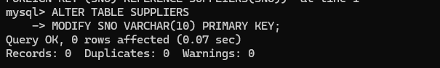

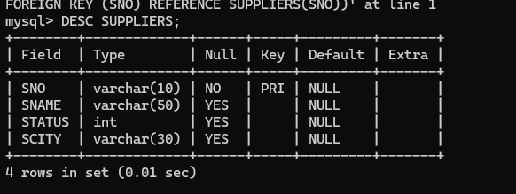

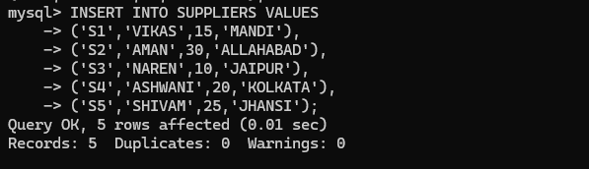

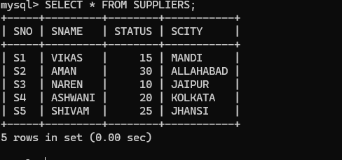

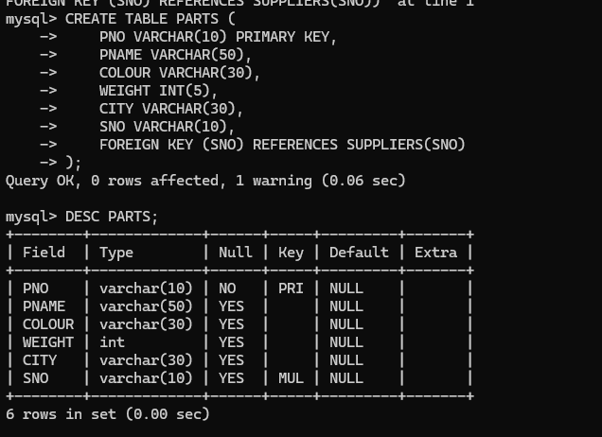

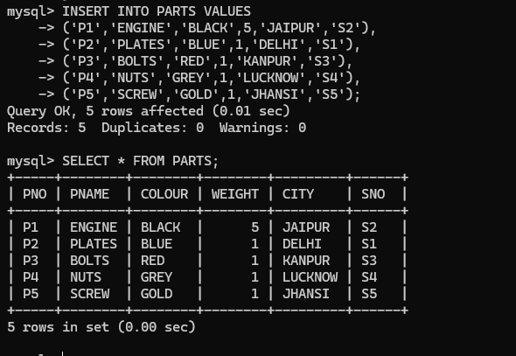

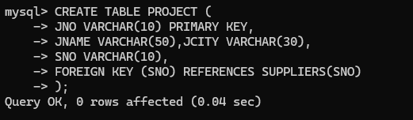

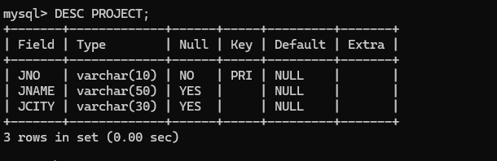

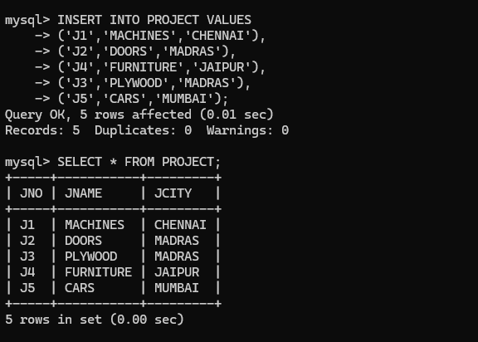

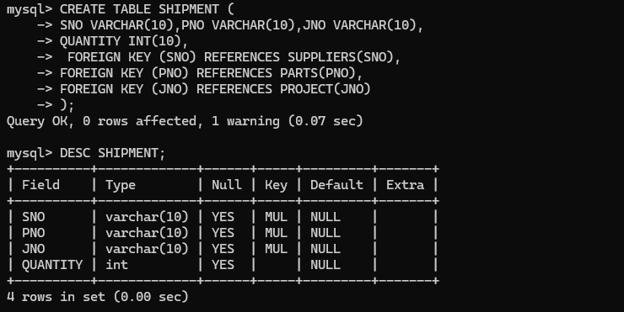

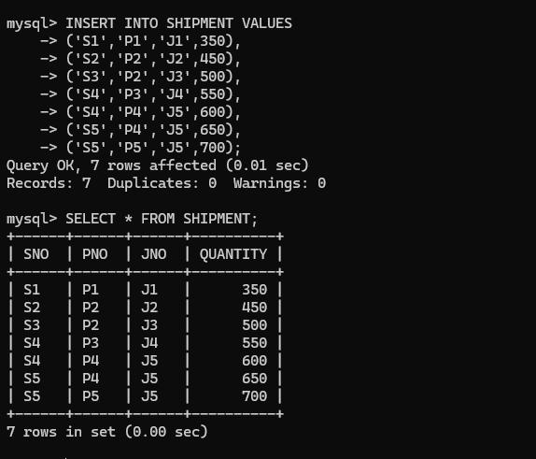

1. Find supplier numbers for suppliers in Mandi with status less than 20.

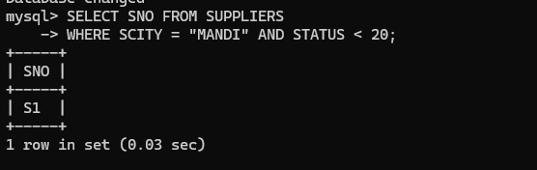

1. Find supplier details for suppliers who supply part P2. Display the supplier list in decreasing order of supplier numbers.

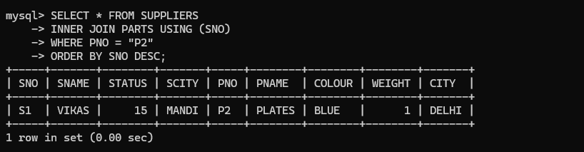

1. Find suppliers names for suppliers who do not supply part P2.

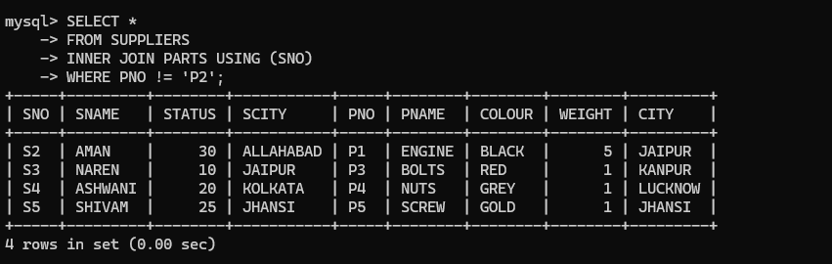

1. For each shipment get full shipment details, including total shipment weights computed as Weight*Quantity of corresponding parts.

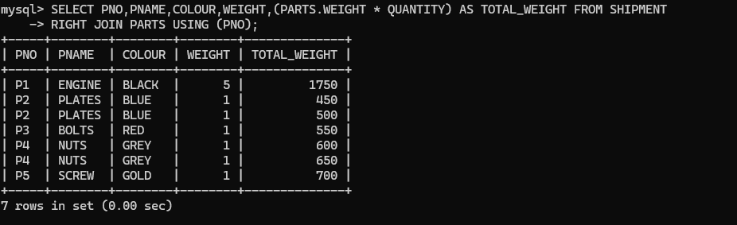

1. Get all the shipments where the quantity is in the range 300 to 750 inclusive.

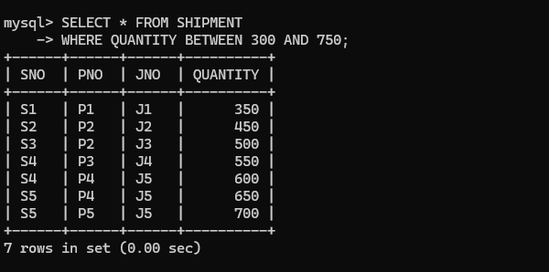

1. Get part numbers for parts that either weigh more than 1Kg or are supplied by suppliers S2 or both.

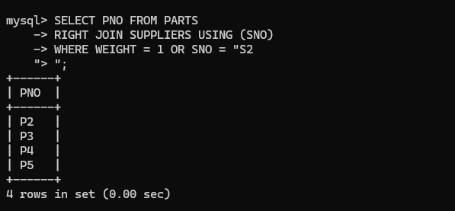

1. Get the names of cities that store more than two red parts. Change the column name in the output to “City-Parts”.

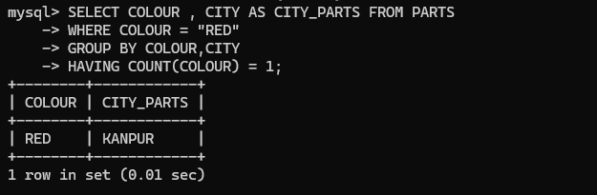

1. Update the city of supplier S1 to “Delhi”.

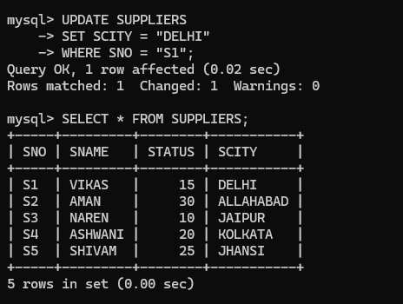

1. Get part numbers for parts supplied by a supplier in Allahabad to a project in Chennai.

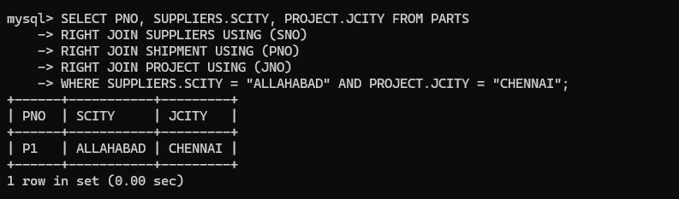

1. Find the names of all parts whose color starts with the letter b.

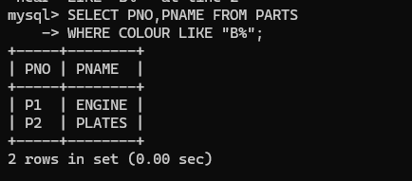

1. Change the datatype of the weight attribute in the Parts table from int to float.

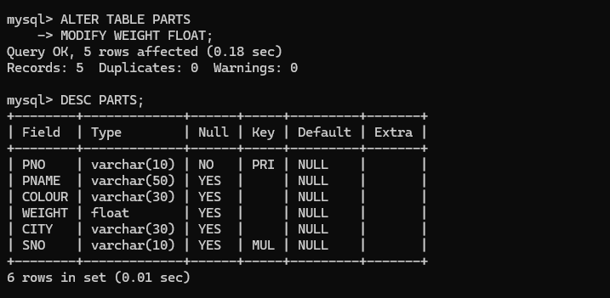

1. Find the number of parts of each color.

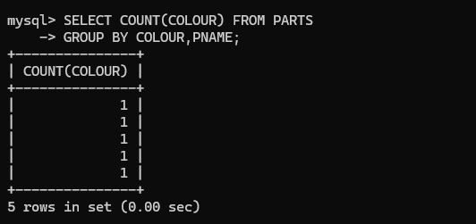

1. Find the names of all the projects which are located in the city Jaipur and in which the part is supplied by supplier S3.

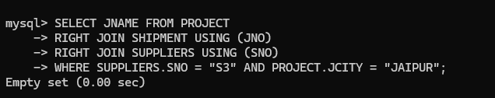

1. Delete all the projects which are located in Madras.

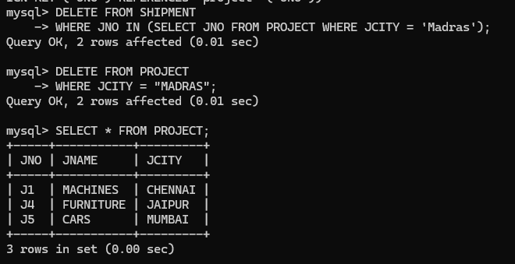

1. Find all part-details of parts that are shipped to any project carried out in Mumbai.

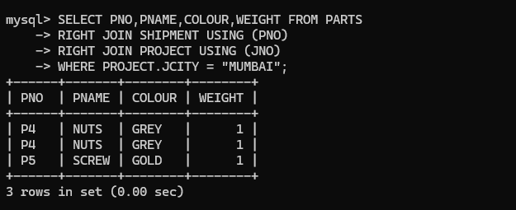

1. Find number of unique projects supplied by supplier S1.

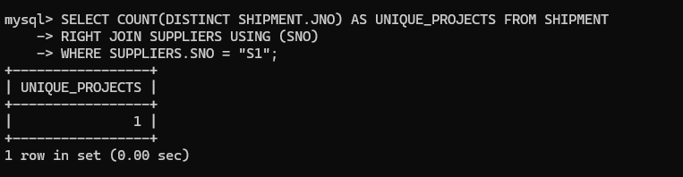

1. Add column SDate in shipment table.

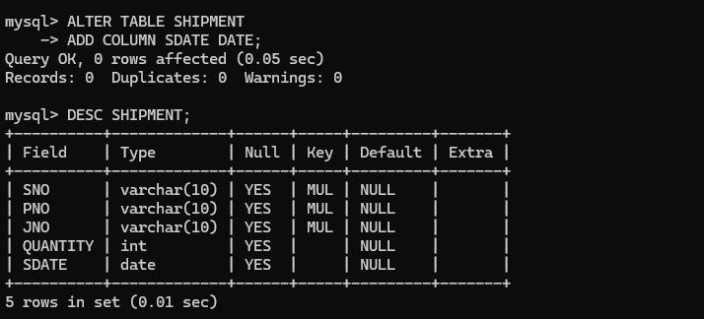

1. For each supplier which supplies parts to a project, find the total no. of parts supplied by the supplier.

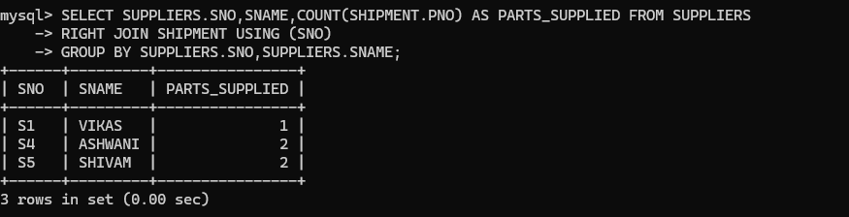

1. Find all supplier name, part name and project name triples such that the indicated supplier, part, and project are all located in the same city. List the name of the city along with the names of suppliers, project and parts.

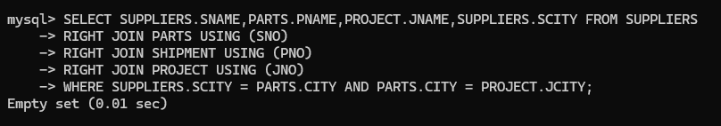

1. Get the names of cities from where more than three yellow parts are supplied.

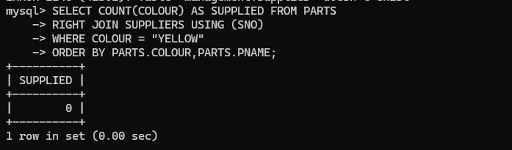

1. Find all distinct cities where either supplier is living or parts are shipped from or projects are carried out. Change the column name in the output to “All-Cities”.

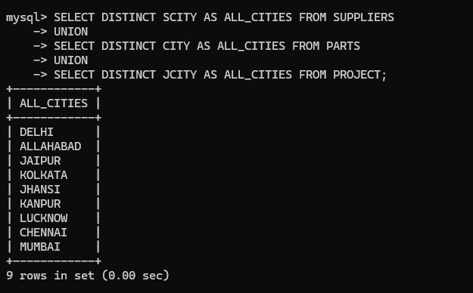

1. Find names of cities such that atleast one supplier is living there and atleast one part is shipped and one project is carried out. Change the column name in the output to “Common-Cities”.

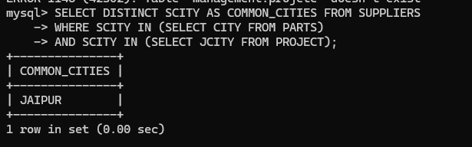

1. Modify data type of any attribute of table shipment.

